Individual Assignment: Case Study
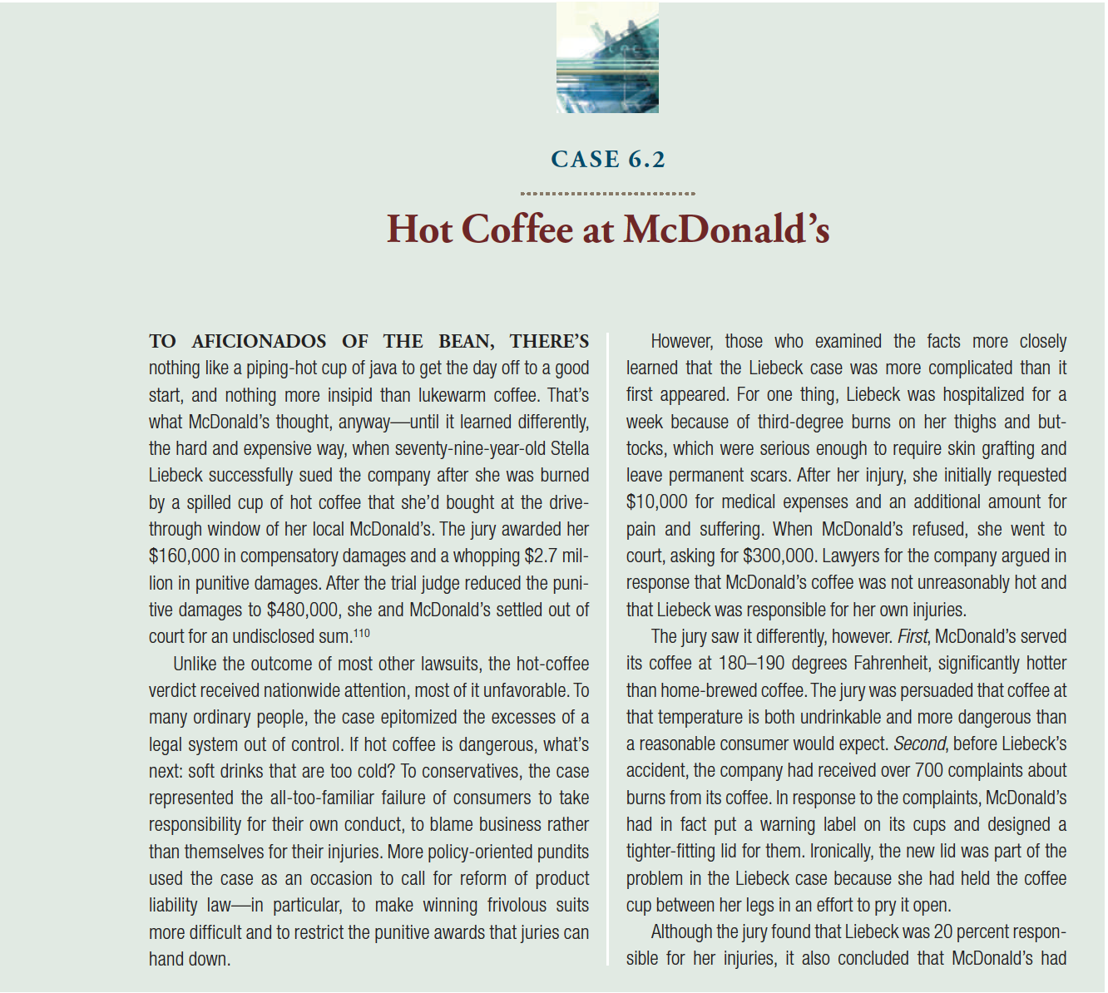
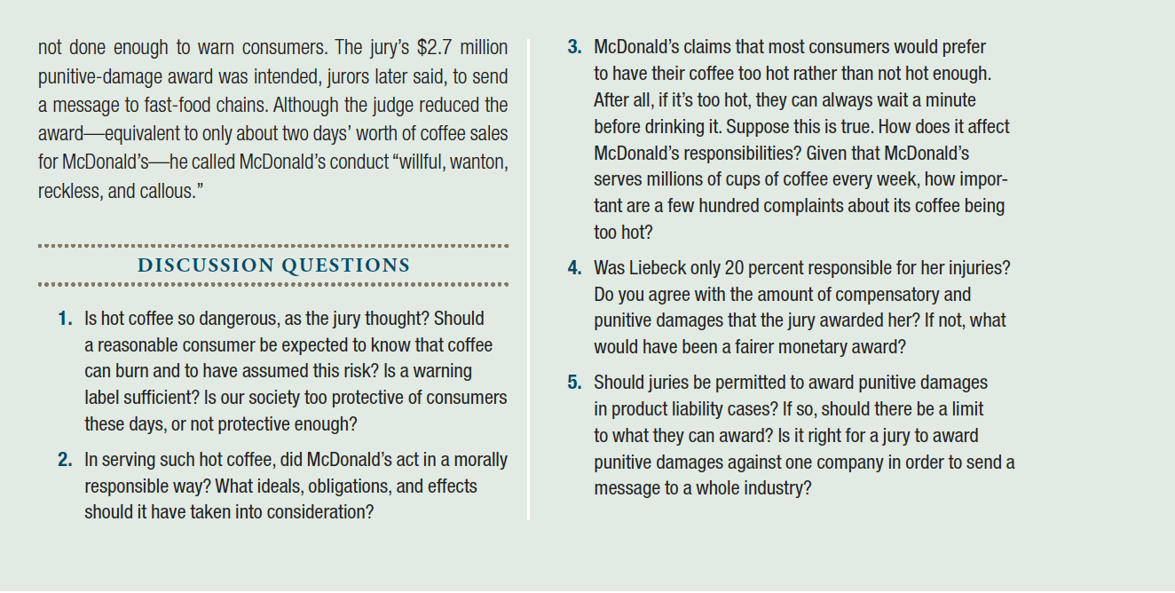
Criteria | Points
Duplicate Case (Failure to select a unique case) | -20 penalty
Comprehensive Summary of Case | 10 points
Explanation of at least 3 Stakeholders (e.g. people, organizations, groups, etc.) affected (harmed or benefitted) by the issues in the case. | 10 points
Explanation of one rule-based theory (Kantian Ethics). Explanation of the key elements of the theories (Imagine you are explaining it to a friend). This should be in your own words (Penalty -5). | 10 points
Explanation of one consequence-based theory (Utilitarian Ethics). Explanation of the key elements of the theories (Imagine you are explaining it to a friend). This should be in your own words (Penalty -5). | 10 points
Application of Kantian Ethics to the case | 10 points
Application of Utilitarian Ethics to the case | 10 points
Compare and contrast results from Kantian and Utilitarian Ethics Application | 10 points
Answer questions 2 & 3 for that case. | 10 points

